**Problem 2**

**The full model:**

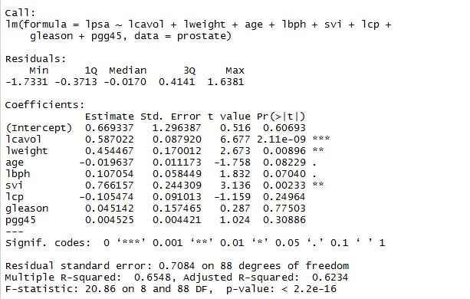

1. **Prediction: 2.419**

**95% PI: (0.994, 3.844)**

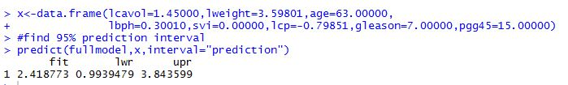

1. **Prediction: 3.263**

**95% PI: (1.530, 5.000)**

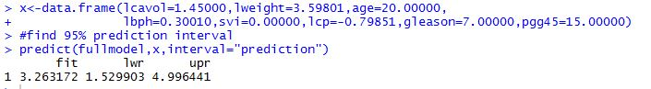

**The reduced model: (variables kept: “lcavol”, “lweight”, and “svi”.**

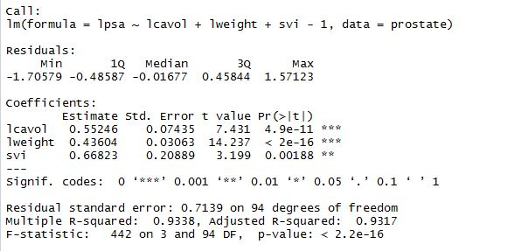

**Prediction: 2.370**

**95% PI: (0.942, 3.798)**

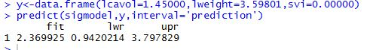

**Problem 3**

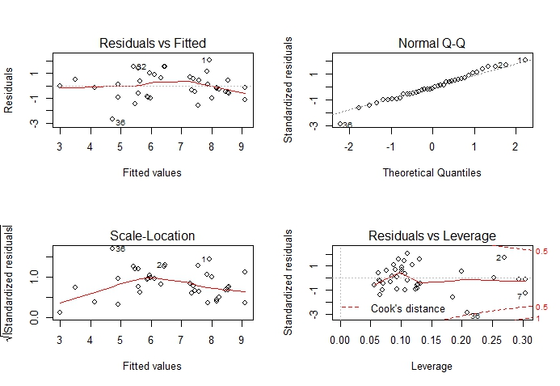

1. By looking at the left-bottom plot (Scale-Location), we can see that the square root of the absolute value of residuals does not maintain well a flat pattern, especially at the lower end, indicating some problems with the constant variance assumption. Cases 1, 2, and 36 may be worth taking a look at.
2. According to the Q-Q plot (top-right corner), we can see that normality is met by most part, except for the lower end, where several observations are off the straight line. Again, we might want to be careful with cases 1, 2, and 36.
3. Using the code below, we can obtain the cases whose leverages are twice or three times as large as the mean leverage,

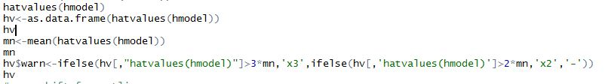

**And here’s what we got, and turns out Cases 2, 6, 7, and 10 have large leverages, and they are larger than twice the mean leverage.**

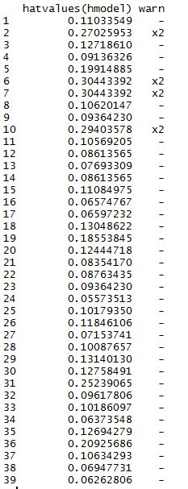

1. According to the mean shift test (code shown below), we can say that there are there’s no outliers.

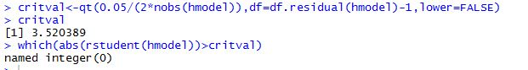

1. According to the Residuals vs. Leverage plot (right-bottom corner), we can see that most of the cases are fine, not exceeding either Cook’s D=1. We can conclude that there’re no influential points.

**Problem 4**

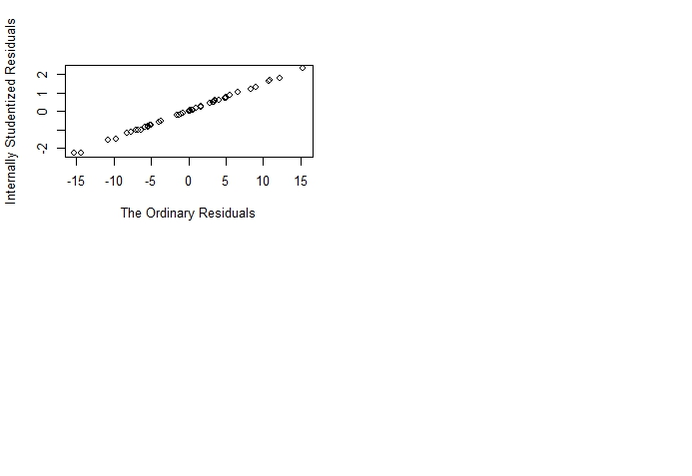

**(c)**

